eLumen Training: Field Validation Rules Guidance

Field Validation Rules

When editing a course workflow, some parts, fields, or field options will be shown or hidden based on values entered in other fields. These dependencies are governed by field validation rules intended to enforce federal, state, and district regulations, policies, and procedures (see Appendix).

Whenever a value is selected in a field that has an associated rule, it will be validated against that rule. (This may take time.) Once validated, if the selected value conflicts with another field value or if a required value is missing, a notice will appear in the Workflow Tools>Workflow Guide>Internal Rules Validation list. The notice will cite the dependent fields involved and what values are available to choose from. The notice may also contain a hyperlink (in blue) that will navigate to the relevant step or part containing the cited field.
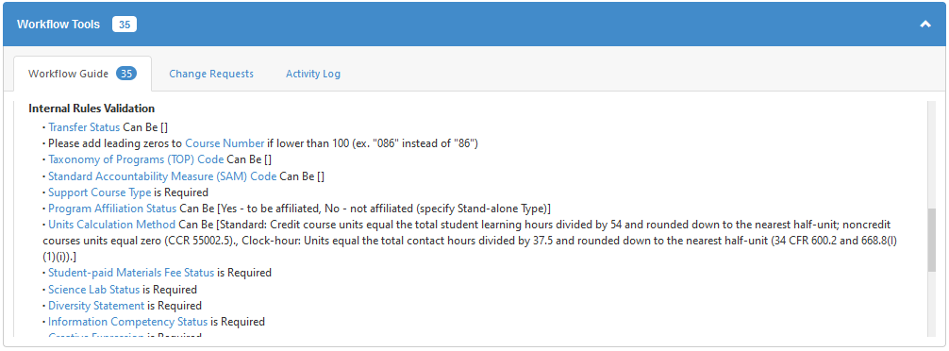

Dependent and Complex Fields
The following are fields governed by validation rules and/or that may be more challenging to navigate. Each is listed under its step and part headings.

Proposal
- Course Identity
  - Subject: depends on faculty discipline
  - Number: depends on cooperative education/directed study status, see Subject
  - Suffix: see Suffix
  - Course Title (CB02): depends on coop ed/directed study status, see Subject
  - Taxonomy of Programs (TOP) Code (CB03): depends on many CB codes, see Course Basic
  - Standard Accountability Measure (SAM) Code (CB09): depends on TOP code, CTE status, program affiliation, and apprenticeship status, see Course Basic
  - Course Family: depending on subject, will only appear if Learning Outcomes>Repeatability>Active Participation Status=Yes

Affiliations
- Program Affiliations: non-editable; will list active programs in eLumen to which the course belongs
- Transferability, GE, Articulation, Cross-listing
  - Course General Education Status (CB25): non-editable; depends on subject (English, E.S.L., math, statistics), transfer status, GE area, and math competency status
  - Transfer Status (CB05): non-editable; articulation officer will maintain
- Function
  - Program Affiliation Status: use only when an affiliated program is not yet active
  - Course Program Status (CB24): non-editable; depends on program affiliations
  - Apprenticeship Status: only appears when program-applicable
  - Planned Apprenticeship; only appears if part of a planned program
  - Stand-alone Type: only appears when not program-applicable
  - Cooperative Work Experience Education Status (CB10) : depends on subject/number, see Subject
  - Passing Grade Meets Math Competency for all AA/AS degrees: non-editable; depends on TOP code (17##.##) and prior-to-transfer level (CB21=Y or A)
  - Basic Skills Status (CB08): depends on subject, TOP code, and prior-to-transfer level, see Prior-to-Transfer Levels
  - Remedial Course Status: non-editable: depends on basic skills status
  - Prior-to-College Status (CB21): depends on TOP code, credit status, transfer status, and basic skills status, see Prior-to-Transfer Levels
  - Credit Status (CB04): depends on subject, transfer status, coop ed status, prior-to-transfer status and program applicability, see Course Basic
  - Noncredit Category (CB22): credit courses must list Y; otherwise depends on subject, TOP code, SAM code, special class status, and basic skills status, see Noncredit Category
  - Course Classification Status (CB11): depends on credit status, noncredit category, and program status, see Course Basic
  - Support Course Type, and Support Course Status (CB26): see Support Course Status

Hours/Units
- Profile: use only for variable hour/unit courses; add new profile for “Maximum” and change default profile to “Minimum”

- Contact Hours per Week: for variable hours/units courses enter minimum values in “Minimum” profile and maximum values in “Maximum profile
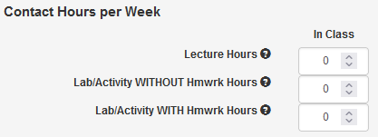

- Weekly Specialty Hours: leave this part blank
- Hour and Units per Term: these fields will auto-calculate based on credit status and contact hours, cooperative education hours or clock hours field values; see Units
- Units Calculation Method: for non-cooperative education courses, select standard method or clock hour method, the coop ed method will auto-select for coop ed courses; see Units
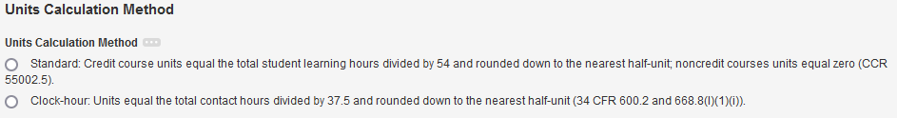

  - Standard: typical of most credit courses, units will auto-calculate, based on the standard formula
  - Clock-hour Method: only for courses in vocational programs with strict external requirements; if selected, fields will appear for minimum/maximum clock hours; units will auto-calculate based on values entered in those fields
  - Cooperative Work Experience Method: additional fields will appear for minimum/maximum paid/unpaid hours; units will auto-calculate based on values entered in those fields; see the instructions below*
- To Be Arranged (TBA): if selected, additional fields will appear for TBA hours (which cannot exceed the total contact hours) and activities (which must be equal to or a subset of those listed in the course content)

* Cooperative Work Experience: Courses in the COOP ED subject or with a number of 911, 921, 931, or 941 are designated as cooperative work experience and are subject to the following special processes.
  - Course basic code CB10 must be “C,” which should be selected automatically, based on the subject or number.
  - The title must follow this convention: “Cooperative Education – [specify topic].”
  - Hours/Units>Unit Calculation Method>Coop Ed must be selected, which will make fields appear for specifying the minimum and maximum paid and unpaid work hours.
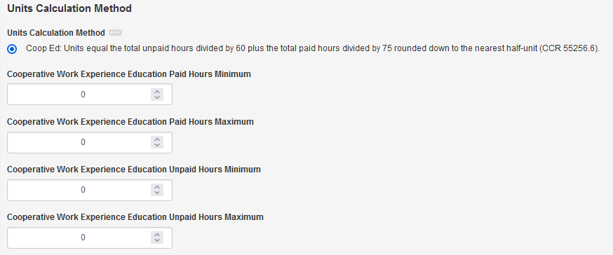

  - Since paid and unpaid hours use a different unit calculation denominator, if both are entered and/or if there is range of hours in either, the resulting hours and/or units will be a range. To enter this range, do the following:
    - Next to the “Profile” field, change the name of the default to “Minimum.”
    - Click “Add Profile” and give it the name “Maximum.”
    - In both the “Minimum” and “Maximum” profiles, makes sure the cooperative work experience calculation method is selected and both the minimum and maximum hours of both paid and unpaid hours are entered underneath it.
    - Above that, in the Contact Hours per Week, enter the total hours as Lab/Activity (without homework; ratio 3:0)—use the Minimum profile to enter the minimum values, and the Maximum for the maximum.

Conditions on Enrollment (requisite, advisory, and non-course)
- Enrollment>Course Prerequisites…, select “Add Group,” (Note: “Anti-requisites” are typically used for equivalent courses the completion of which prevents enrollment in the other, for example MATH 227 and MATH 227S.)
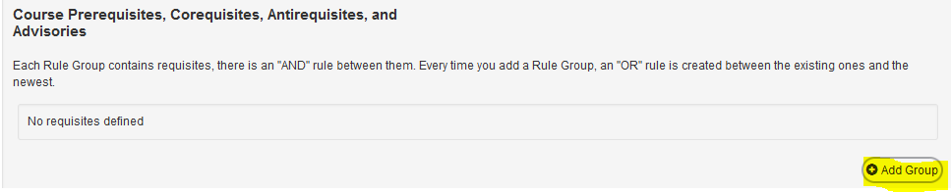

  - Select Course Condition Type, then the Course, then click “Add Requisite.”
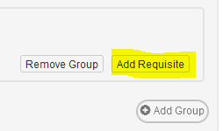

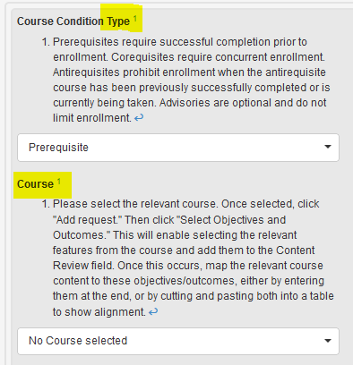

  - Select Objectives and Outcomes: this enables selecting relevant objectives and outcomes from the requisite course (if present in its outline), which will then be copied into the above field; Using the Select Objectives and Outcomes button, select the options representing the requisite skills required, then “Add.” Otherwise, enter the requisite skills in the textbox.
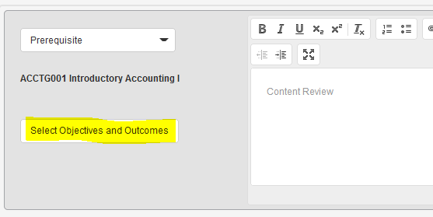

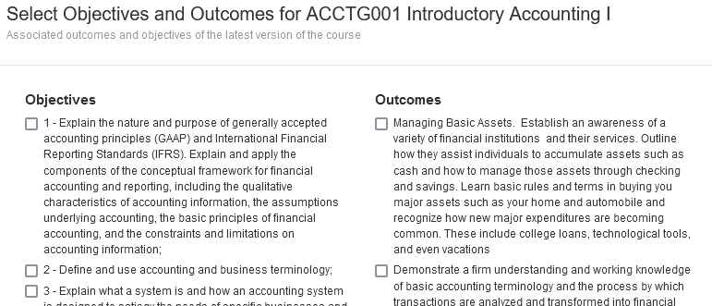

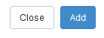

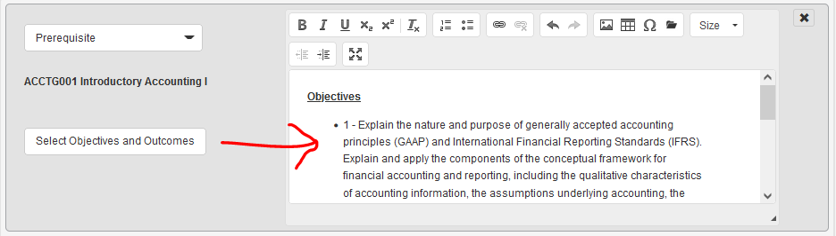

  - If additional are required, follow the above steps. Note: This will automatically add an “or” condition between groups. For “and” conditions, use “Add requisite” within the same group. Create a group for every possible combination of “or” sets.
- Course Conditions on Enrollment Content Review>Target Course Content: Enter current “target” course content for which the prerequisite skills are necessary. The combination of this and the previous fields enables the mapping of requisite skills to the target course content in order to show how the requisite course is necessary in order to meet the objectives of the target course.
- Non-course Conditions: may include conditions such as placement into transfer-level English/math, an audition for a theater production course, or a negative TB test for a nursing course; the most commonly used may be checked, or an “other” specified
- Conditions on Enrollment (COE) Validation: select the criteria used to validate the requisites
- Student Fee: if an amount is entered, additional fields will appear for validating the fee

Learning Outcomes
- Course Objectives and Student Learning Outcomes: enter each one separately (not as a list within a single field); it is advisable to number each for reference
- Student Learning Outcomes>Expected SLO Performance: a percentage must be added for each SLO
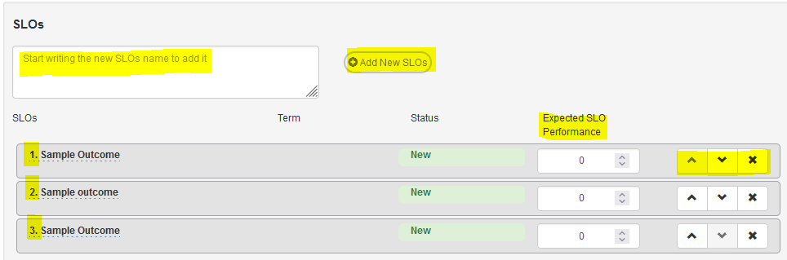

- Content: if contact hours are listed as “lecture,” enter content for those hours in the appropriate field (and do the same for lab/activity content in its own field as below)
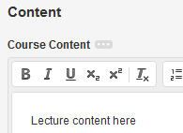

- Lab/Activity Status: if contact hours are listed as “lab,” select yes; then enter the lab/activity hours content in the field that appears
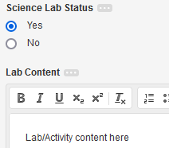

- Learning Outcomes>Textbooks/Content Resources
  - How many textbooks/content resources will be added below?: There are several fields required for each textbook/content resource entry. To limit the amount of space used by them, any entries beyond the first two must be entered in table format in the “Additional Textbooks/Content Resources” field. Instructions on how to create such a table follow below. But please note: in order to be able to search all courses for textbook recency, make sure that the most recent entries are entered first, using the separated fields. Then list any additional in the table.
  - Start by indicating how many entries will be entered: 1, 2, or 3+ (three or more).
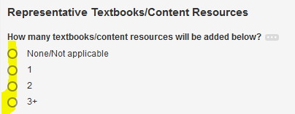

    - Then additional fields will appear for each of the first two textbooks (labeled “1” or “2”).
    - Note: Just under the above is “Additional Student-provided Resources Required.” This is not for entering textbooks, but rather materials such as calculators, safety equipment, etc. that is required in addition to the textbooks/resources.
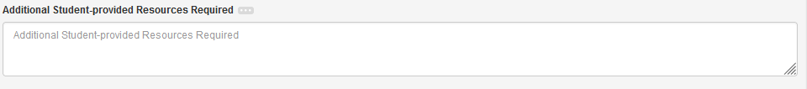

  - Additional Textbooks/Content Resources: If three or more are required, please enter them in table format.
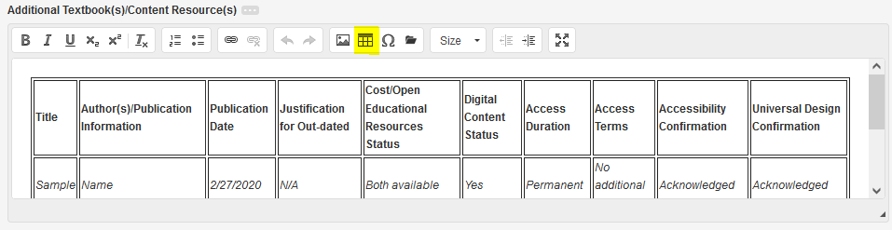

    - The format should be auto-populated. If not, either cut-and-paste the following, or click the table icon in the editing tools to recreate it.
Title | Author(s)/ Publication Information | Publication Date | Justification for Out-dated | Cost/Open Educational Resources Status | Digital Content Status | Access Duration | Access Terms | Accessibility Confirmation | Universal Design Confirmation
Sample | Name | 2/27/202 | N/A | Both available | Yes | Permanent | No additional cost | Acknowledged | Acknowledged

  - For Visual and Performing Arts, Kinesiology, and Academic Competition: Some courses in this set of topics may be eligible to be repeated for credit or to be grouped into “families” of courses similar in content for the purpose of limiting enrollments.
    - Active Participation Status: If “Yes” is selected, then additional fields will appear for specifying repeatability and/or requesting family status.

    - Note: A request for a new course family designation will be treated as a district shared field change, subject to district-wide vetting and possible challenge by another college. If approved, the Curriculum Technician will update the family listing that appears in Proposal>Course Identity>Course Family.
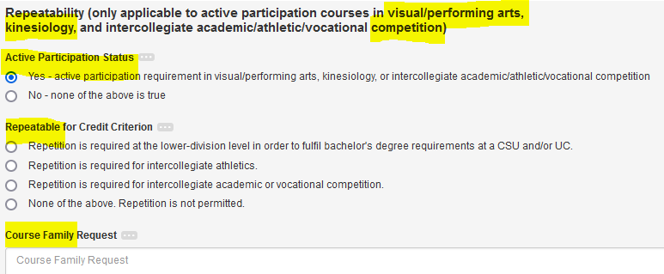

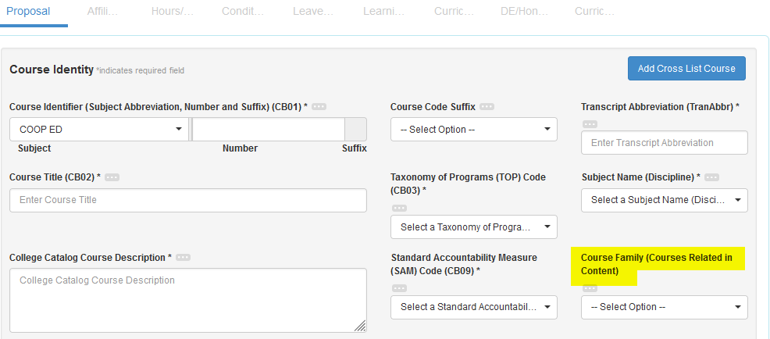

Curriculum Map
- This section can only be completed if student learning outcomes have been entered in the Learning Outcomes step. It is intended to enable mapping the SLOs from this course to relevant program, general education, and/or institutional learning outcomes.
- Once SLOs have been entered, each will be listed in a table, allowing check boxes to be place by the parallel higher-level outcomes.
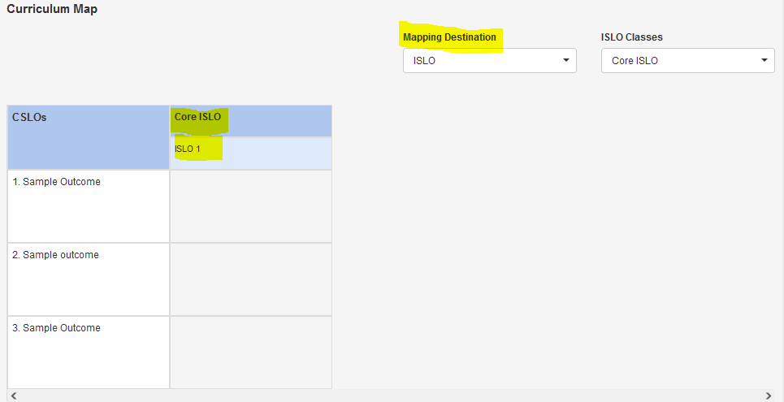

DE/Honors
- If “Yes” is selected for either option, a series of fields will appear.
- Curriculum Technician: do not enter information in fields associated with these parts; they will be entered by the curriculum technician following the approval process and subsequent processes

Curriculum Technician
- The fields in this step are non-editable by the workflow author. They will be entered once the proposal has been reviewed.

Appendix: “The Red Tape”
The following describes how the validation rules work when eligible options in any field are dependent upon what is entered elsewhere, based on state, federal, and district regulations.

Course Basic (CB) Codes
The following were developed by the State Chancellor’s Office to enable reporting of course elements pertaining to various Title 5 regulations.
CB | Name | Options | If | Then
00 | Control Number | COCI value; otherwise YYYYYYYYYYYY | Undefined | See COCI
01 | Department-Number | Concatenate CB01A;CBO1B | Undefined | Concatenate CB01A;CBO1B=unique to term
01A | Subject Abbreviation | See SIS query SR726____SUBJECT_TABLE | Undefined | See CB01 and Suffix Tables
01B | Number | 3 numeric digits plus suffix
02 | Course (Long) Title | COCI/MIS truncates to 68 char | Undefined | See CB01 Table
03 | TOP Code | See CB03 Manual | Undefined | See CB01, CB21, CB22, and CB26 Tables
04 | Credit Status | D - Credit - Degree-applicable  C - Credit - Not degree-applicable  N - Noncredit | D  C | CB06>=CB07>=0.5 and CB22=Y
 |  |  | N | CB05=C and CB06/CB07=0 and CB10=N and CB11=J/K/L and CB22=A/B/C/D/E/F/G/H/I/J
05 | Transfer Status | A - Transferable to UC and CSU  B - Transferable to CSU only  C - Not transferable | A/B | CB04=D and CB19=CB01A and CB20=CB01B
 |  |  | C | CB19=YYYYYYY and CB20=YYYYYYYYY
06 | Units Maximum | ##.## | Undefined | See CB01 Table and Hours-Units Calculator
07 | Units Minimum | ##.## | Undefined | See CB01 Table and Hours-Units Calculator
08 | Basic Skills Status | B - Basic skills course  N - Not basic skills course | B | CB03=150100/152000/170100/493060/  493062/493084/493085/493086/493087/  493090 and CB04=C/N
09 | SAM Priority Code | A - Apprenticeship  B - Advanced occupational  C - Clearly occupational  D - Possibly occupational  E - Non-occupational | A | Required in apprent prog appr by CA Dept of Industrial Relations Div of Apprent Standards
 |  |  | B | CB03=voc and CB24=1 and voc prog and (<=2) capstone crs w/prereq w/CB09=C or coreq w/CB09=B
 |  |  | C | CB03=vocational and CB24=1 and required for vocational program
 |  |  | D | CB03=vocational and CB24=2
 |  |  | E | CB03≠vocational
10 | Cooperative Work Experience Education | N - Not part of coop ed program  C - Part of coop ed program | C | See CB01 Table
11 | Course Classification Status | Y - Credit course  J - Workforce prep enhanced funding  K - Other enhanced funding  L - Non-enhanced funding | Y | CB04=C/D
 |  |  | J  K | CB04=N and CB24=1
 |  |  | L | CB04=N and CB24=2
13 | Special Class Status | S - For students with disabilities  N - Not a special course | S | CB03≠493060/493062 and CB08=N
14 | CAN Code | Default: YYYYYY | Undefined | YYYYYY
15 | CAN Sequence Code | Default: YYYYYYYY | Undefined | YYYYYYYY
19 | Crosswalk Department | Default: YYYYYYY  CB01A | YYYYYYY | CB05=C
 |  |  | CB01A | CB05=A/B
20 | Crosswalk Number | Default: YYYYYYYYY  CB01B | YYYYYYYYY | CB05=C
 |  |  | CB01B | CB05=A/B
21 | Prior-to-college level | Y - Not applicable  A - One level below transfer  B - Two levels below transfer  C - Three levels below transfer  D - Four levels below transfer  E - Five levels below transfer  F - Six levels below transfer  G - Seven levels below transfer  H - Eight levels below transfer | Undefined | See CB21 Table
22 | Noncredit Category | A - ESL  B - Citizenship for immigrants  C - Basic skills  D - Health and safety  E - Persons with substantial disab  F - Parenting  G - Home economics  H - Older adults  I - Short-term vocational  J - Workforce preparation  Y - Not applicable/credit course | CB04=C/D | CB22=Y
 |  |  | CB04=N | See CB22 Table
23 | Funding Agency Category | A - Primarily Economic Dev Funds  B - Partially Economic Dev Funds  Y - Not applicable | A | Economic Dev Funds>40%
 |  |  | B | Economic Dev Funds=1-39%
 |  |  | C | Economic Dev Funds=0%
24 | Program Status | 1 - Program applicable  2 - Not program applicable | 1 | Requirement or restricted elective in degree or transcripted certificate
 |  |  | 2 | CB24≠1
25 | General Education Status | A - [English GE]  B - [Math GE, transferable]  C - [Not B, Math comp]  Y - Not applicable | A | CB05=A/B, and CSUGE=A2/A3//IGETC=1A/1B or artic Eng comp or local written exp compet
 |  |  | B | CB05=A/B, and CSUGE=B4/IGETC=2, or artic math/quant
 |  |  | C | CB05=D and CB25≠B and LACCDGE=D2 and/or CB03=17#### and CB21=Y/A
 |  |  | Y | If CB25=Y, then none of the above is true
26 | Support Course Status | S - Support course  N - Not a support course | Undefined | See CB26 Table

Subject (CB01A)
When you operate in the “Faculty” role, the list of available subjects is limited to what you teach. Depending on those subjects, the following dependencies may affect your options.
If CB01A | And if | Then
Any | CB01B=185 | CB02="Directed Studies - [CB01A]", CB06/07=1.0
Any | CB01B=285 | CB02="Directed Studies - [CB01A]", CB06/07=2.0
Any | CB01B=385 | CB02="Directed Studies - [CB01A]", CB06/07=3.0
Any | CB01B=485 | CB02="Directed Studies - [CB01A]", CB06/07=4.0
Any | CB01B=911 | CB02="Cooperative Work Experience - [CB01A]", CB04=D, CB06/07=1.0, CB08=N, CB10=C, CB21=Y, CB22=Y, using Coop Ed unit calc method
Any | CB01B=921 | CB02="Cooperative Work Experience - [CB01A]", CB04=D, CB06/07=2.0, CB08=N, CB10=C, CB21=Y, CB22=Y, using Coop Ed unit calc method
Any | CB01B=931 | CB02="Cooperative Work Experience - [CB01A]", CB04=D, CB06/07=3.0, CB08=N, CB10=C, CB21=Y, CB22=Y, using Coop Ed unit calc method
Any | CB01B=941 | CB02="Cooperative Work Experience - [CB01A]", CB04=D, CB06/07=4.0, CB08=N, CB10=C, CB21=Y, CB22=Y, using Coop Ed unit calc method
ACAD PR |  | CB04=N, CB10=N
BSICSKL |  | CB04=N, CB10=N
CITIZN |  | CB04=N, CB10=N
COOP ED | CB03≠ Vocational | CB04=D, CB06<=6.0, CB07>=0.5, CB10=C, use Coop Ed unit calc method
COOP ED | CB03= Vocational | CB04=D, CB06<=8.0, CB07>=0.5, CB10=C, use Coop Ed unit calc method
DEV COM |  | CB04=C, CB10=N
E.S.L. |  | CB04=C/D, CB10=N
ESL |  | CB04=C/D, CB10=N
ENGLISH |  | CB04=C/D, CB10=N
ESL NC |  | CB04=N, CB10=N
ESLCVCS |  | CB04=N, CB10=N
HLTHED |  | CB04=N, CB10=N
LRNFDTN |  | CB04=C, CB10=N
LRNSKIL |  | CB04=C, CB10=N
LRNSKL |  | CB04=C, CB10=N
MATH |  | CB04=C/D, CB10=N
MATH NC |  | CB04=N, CB10=N
OLD ADL |  | CB04=N, CB10=N
PARENT |  | CB04=N, CB10=N
READING |  | CB04=C/D, CB10=N
TUTOR |  | CB04=N, CB10=N
VOC ED |  | CB04=N, CB10=N
Not above |  | CB04=C/D, CB10=N

Suffix
The LACCD employs course suffixes (characters that follow the number) to add meta-data to a course identifier. The following lists suffixes and any dependencies that apply to them.
If Suffix |  | Then
L | Laboratory | Lab/Activity Hrs/Wk>0
CE | Noncredit ""Continuing Education"" | CB01A≠TUTOR and CB04=N
X | Transfer-level English, ESL, math or statistics course with 1 hour of supplemental support | CB25=A/B/C
Y | Transfer-level English, ESL, math or statistics course with 2 hours of supplemental support | CB25=A/B/C
Z | Transfer-level English, ESL, math or statistics course with 3 hours of supplemental support | CB25=A/B/C
S | Transfer-level English, ESL, math or statistics course with hours of supplemental support that may vary by college | CB25=A/B/C
-1 | Same-topic sequence level 1 | Is Prereq/Adv for -2
-2 | Same-topic sequence level 2 | Prereq/Adv=-1
-3 | Same-topic sequence level 3 | Prereq/Adv=-2
-4 | Same-topic sequence level 4 | Prereq/Adv=-3
T | Noncredit course in the Tutoring (TUTOR) subject | CB01A=TUTOR
A | Module A (formerly within a single course) | Same CB01 (except suffix) as others in set
B | Module B (formerly within a single course) | Same CB01 (except suffix) as others in set
C | Module C (formerly within a single course) | Same CB01 (except suffix) as others in set
D | Module D (formerly within a single course) | Same CB01 (except suffix) as others in set
E | Module E (formerly within a single course) | Same CB01 (except suffix) as others in set
F | Module F (formerly within a single course) | Same CB01 (except suffix) as others in set
G | Module G (formerly within a single course) | Same CB01 (except suffix) as others in set
I | Module I (formerly within a single course) | Same CB01 (except suffix) as others in set
J | Module J (formerly within a single course) | Same CB01 (except suffix) as others in set
K | Module K (formerly within a single course) | Same CB01 (except suffix) as others in set
M | Module M (formerly within a single course) | Same CB01 (except suffix) as others in set
N | Module N (formerly within a single course) | Same CB01 (except suffix) as others in set
P | Module P (formerly within a single course) | Same CB01 (except suffix) as others in set
Q | Module Q (formerly within a single course) | Same CB01 (except suffix) as others in set
R | Module R (formerly within a single course) | Same CB01 (except suffix) as others in set

Prior-to-Transfer Levels (CB21)
Courses with content parallel grades 5-12 or in sequences prior to college-level must be coded as such. The following shows how this code must be assigned. Note: The State Chancellor’s Office data element dictionary contains contradictory coding instructions. They are also noted below along with how the LACCD has attempted to resolve them.
If |  |  |  |  | Then
CB03 | Topic | CB04 | CB05 | CB08 | CB21
150100/ 152000 | Writing/ Reading | D | A/B | N | Y
150100/ 152000 | Writing/ Reading | D | C | N | Y*/A
150100/ 152000 | Writing/ Reading | C | C | N | Y*/A/B/C/D
150100/ 152000 | Writing/ Reading | C | C | B | A/B/C/D
150100 | Writing | N | C | B | A/B/C/D/E/F
152000 | Reading | N | C | N | Y
170100 | Mathematics, General | D | A/B | N | Y
170100 | Mathematics, General | D | C | N | Y*/A/B
170100 | Mathematics, General | C | C | N | Y*/A/B/C/D
170100 | Mathematics, General | C | C | B | A/B/C/D
170100 | Mathematics, General | N | C | N | Y
170100 | Mathematics, General | N | C | B | A/B/C/D/E/F
493062 | Secondary Education (Grades 9-12) and GED: NOT Reading, Writing, Computation, or ESL | N | C | N** | Y
 | Secondary Education (Grades 9-12) and GED: Reading, Writing, Computation, or ESL | N | C | B | A/B/C***
493060 | Secondary Education (Grades 1-8): NOT Reading, Writing, Computation, or ESL | N | C | N** | Y
 | Secondary Education (Grades 1-8): Reading, Writing, Computation, or ESL | N | C | B | D/E/F***
493084/ 493085/ 493086/ 493087 | ESL Writing/ Reading/ Listening & Speaking/ Integrated | D | A/B/C | N | Y/A/B/C/D/E/F
493084/ 493085/ 493086/ 493087 | ESL Writing/ Reading/ Listening & Speaking/ Integrated | C | C | N | Y*/A/B/C/D/E/F
493084/ 493085/ 493086/ 493087 | ESL Writing/ Reading/ Listening & Speaking/ Integrated | C | C | B | A/B/C/D/E/F
493084/ 493085/ 493086/ 493087 | ESL Writing/ Reading/ Listening & Speaking/ Integrated | N | C | B | A/B/C/D/E/F
493090/ 493100 | Citizenship/ ESL Civics/ Vocational ESL | N | C | N | Y
493100 | Vocational ESL | N | C | B | A/B/C/D/E/F
493090 | Citizenship/ESL Civics | N | C | B | A/B/C/D/E/F/G/H
Not above |  | D/C/N | A/B/C | N | Y
*MIS DED CB21 does not list Y. However, courses that are not basic skills should be able to be college level.
**MIS DED CB21 does not list CB08=N as an option for this row. However, assuming the CB21 Y option is not a typo, it is assumed to apply only to courses that are not basic skills, thus CB08=N.
***MIS DED CB21 includes Y. However, since basic skills courses cannot be college level, see **.

Noncredit Category (CB22)
The following shows the criteria for applying the noncredit category code to a course. As with CB21, contradictory coding instructions and/or LACCD resolutions have been noted.
If |  | Then CB04=N, CB05=C, CB06/07=0, CB11=J/K/L, and...
CB22 |  | CB03 | CB08 | CB09
A | ESL (English as a Second Language) | 493084/ 493085/ 493086/ 493087 | B/N
B | Immigrant Education (Citizenship/Civic Education) | 220120/ 220500/ 220700 | N
 |  | 493090 | B/N
C | Elementary & Secondary Basic Skills | 150100/ 152000/ 170100 | B
 |  | 170200/ 493009/ 493014/ 493030/ 493031/ 493032/ 493033 | B*
 |  | 493060/ 493062 | B
D | Health & Safety | 083510/ 083570/ 083580/ 083700/ 089900/ 129900/ 130600/ 139900/ 210400/ 210440/ 210450/ 210530/ 213300/ 219900 | N
E | Substantial Disabilities | Any (except those used for basic skills**) | N
F | Parenting | 1305##/ 130800 | N
G | Home Economics/Family & Consumer Science | 13#### | N
H | Older Adults | Any (except those used for basic skills**) | N
I | Short-term Vocational Program/Career Technical | Vocational (except 493100) | N | A/B/C/D
J | Workforce Preparation | 493010/ 493011/ 493012/ 493013/ 493072 | N
 |  | Vocational (except 493100)*** | N
*MIS DED CB21 does not list as B-eligible
**493060/493062 and any others with CB08=B
***MIS DED CB03 does not include this provision

Support Course Status (CB26)
Courses that are included in a college’s placement model as supporting transfer-level English, math, or statistics courses are coded as support courses (S). The conditions under which a course may be included in a placement model are defined in Title 5, Section 55522. The following is how those conditions are implemented in the LACCD as approved by the District Academic Senate.
If CB03 is listed below and CB25=Y and the course is included in a placement milestone, and... |  |  | Then CB26=S and see below; otherwise, CB26=N
If |  | And if | And
CB03 | 15####/ 17####/ 493062 |  | CB21=A, No prerequisites
 | 493009/ 493084/ 493085/ 493086/ 493087 | CB21=A/B/C/D | 0-1 Prerequisite
 | 493009/ 493084/ 493085/ 493086/ 493087 | CB21=E | No prerequisites
CB04 | C |  | CB22=Y
 | N | CB03=15####/17####/493062 | CB22=C
 |  | CB03=493009/ 493084/ 493085/ 493086/ 493087 | CB22=A
CB05 |  |  | C
CB06 |  | Concurrent support course option | <=1.0
 |  | Preparatory support course only | <=3.0
CB07 |  | CB04=C | >=0.5
CB08 |  |  | B (Remedial course designation)
CB09 |  |  | E
CB10 |  |  | N
CB11 |  |  | K/L/Y
CB22 |  | CB04=C
 |  | CB04=N | A/C
CB24 |  | CB04=N | 2-Jan
 |  | CB04=C | 2
CB26 | S | Concurrent support course option | Lab/Act without homework Hrs/Wk<=3
 |  | Preparatory support course only | In-class Hrs/Wk<=6  Out-of-class Hrs/Wk<=6
CB26 | S |  | Financial Aid Eligible

Units (CB06-Maximum/CB07-Minimum)
Noncredit courses generate zero units. Credit courses generate units based on the following formulae as codified in LACCD Administrative Procedures AP 4022.
- Student Learning Hours: The sum of the total contact hours plus the total out-of-class hours counted toward units. Out-of-class hours are calculated based on the type of contact hour. 1 unit is generated for each of the following contact hour type to out-of-class hour ratios:
  - 1:2 1 hour of lecture to 2 hours out-of-class
  - 2:1 2 hours lab to 1 hour out-of-class
  - 3:0 3 hours lab (no out-of-class hours factored into the calculation)
- Standard Units: Total Student Learning Hours divided by 54 and then rounded down to the nearest half-unit. When a course allows the student to attend a range of hours, the units must also be expressed as a range (minimum to maximum), based on that range.
- Cooperative Work Experience Education Units: The range (minimum to maximum) resulting from the following, rounded down to the nearest half-unit, where the maximum is not to exceed 8 units of “occupational” (i.e., in a course having a vocational TOP code) or 6 units of “non-occupational” cooperative work experience.
  - Total unpaid contact hours divided by 60.
  - Total paid contact hours divided by 75.
- Clock Hour Units: Total contact hours (not student learning hours) divided by 37.5 and rounded down to the nearest half-unit.

